Experiment-5

Name: Milan Jani

Enroll No.: 92301733041
AIM: Design FIR filter with windowing method.
import numpy as np
import matplotlib.pyplot as plt
from scipy.io import wavfile
from scipy.io.wavfile import write

from scipy.signal import butter, lfilter, firwin, freqz

def plot_fft(signal, fs, title):
N = len(signal)
freq = np.fft.rfftfreq(N, d=1/fs)
fft_mag = np.abs(np.fft.rfft(signal))

plt.figure(figsize=(10, 4))
plt.plot(freq, fft_mag)
plt.title(title)
plt.xlabel("Frequency (Hz)")
plt.ylabel("Magnitude")
plt.grid(True)
plt.tight_layout()
plt.show()

def apply_IIR_filter(signal, cutoff, fs, order=6):
b, a = butter(order, cutoff / (fs/2), btype="low")
filtered = lfilter(b, a, signal)
return filtered

def apply_FIR_filter(signal, cutoff, fs, numtaps=101):
fir_coeff = firwin(numtaps, cutoff / (fs/2), window="hann")
filtered = np.convolve(signal, fir_coeff, mode='same')
return filtered

def correlation(clean, test):
min_len = min(len(clean), len(test))
return np.corrcoef(clean[:min_len], test[:min_len])[0,1]

clean_fs, clean = wavfile.read("C:/Users/DJ/Downloads/FIR Filter/FIR Filter/Original.wav")
noise1_fs, noise1 = wavfile.read("C:/Users/DJ/Downloads/FIR Filter/FIR Filter/sp30_car_sn5.wav")
noise2_fs, noise2 = wavfile.read("C:/Users/DJ/Downloads/FIR Filter/FIR Filter/sp30_train_sn5.wav")
noise3_fs, noise3 = wavfile.read("C:/Users/DJ/Downloads/FIR Filter/FIR Filter/sp30_station_sn5.wav")

# Convert to float
clean = clean.astype(float)
noise1 = noise1.astype(float)
noise2 = noise2.astype(float)
noise3 = noise3.astype(float)

plot_fft(clean, clean_fs, "FFT of Clean Speech")
plot_fft(noise1, noise1_fs, "FFT of Noisy Speech 1")
plot_fft(noise2, noise2_fs, "FFT of Noisy Speech 2")
plot_fft(noise3, noise3_fs, "FFT of Noisy Speech 3")

cutoff = 3000 # you can adjust based on spectrum

iir_noise1 = apply_IIR_filter(noise1, cutoff, noise1_fs)
iir_noise2 = apply_IIR_filter(noise2, cutoff, noise2_fs)
iir_noise3 = apply_IIR_filter(noise3, cutoff, noise3_fs)

corr_iir_1 = correlation(clean, iir_noise1)
corr_iir_2 = correlation(clean, iir_noise2)
corr_iir_3 = correlation(clean, iir_noise3)

print("\n===== IIR Filtering Correlation with Clean Speech =====")
print("Noise 1:", corr_iir_1)
print("Noise 2:", corr_iir_2)
print("Noise 3:", corr_iir_3)

fir_noise1 = apply_FIR_filter(noise1, cutoff, noise1_fs)
fir_noise2 = apply_FIR_filter(noise2, cutoff, noise2_fs)
fir_noise3 = apply_FIR_filter(noise3, cutoff, noise3_fs)

corr_fir_1 = correlation(clean, fir_noise1)
corr_fir_2 = correlation(clean, fir_noise2)
corr_fir_3 = correlation(clean, fir_noise3)

print("\n===== FIR Filtering Correlation with Clean Speech =====")
print("Noise 1:", corr_fir_1)
print("Noise 2:", corr_fir_2)
print("Noise 3:", corr_fir_3)

def normalize_audio(sig):
sig = sig / np.max(np.abs(sig))
return (sig * 32767).astype(np.int16)

# ---- IIR Output Files ----
write("iir_noise1.wav", noise1_fs, normalize_audio(iir_noise1))
write("iir_noise2.wav", noise2_fs, normalize_audio(iir_noise2))
write("iir_noise3.wav", noise3_fs, normalize_audio(iir_noise3))

# ---- FIR Output Files ----
write("fir_noise1.wav", noise1_fs, normalize_audio(fir_noise1))
write("fir_noise2.wav", noise2_fs, normalize_audio(fir_noise2))
write("fir_noise3.wav", noise3_fs, normalize_audio(fir_noise3))

print("\n✅ All filtered audio files saved successfully!")

Output:

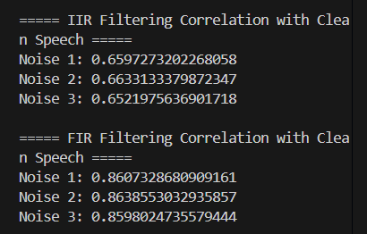
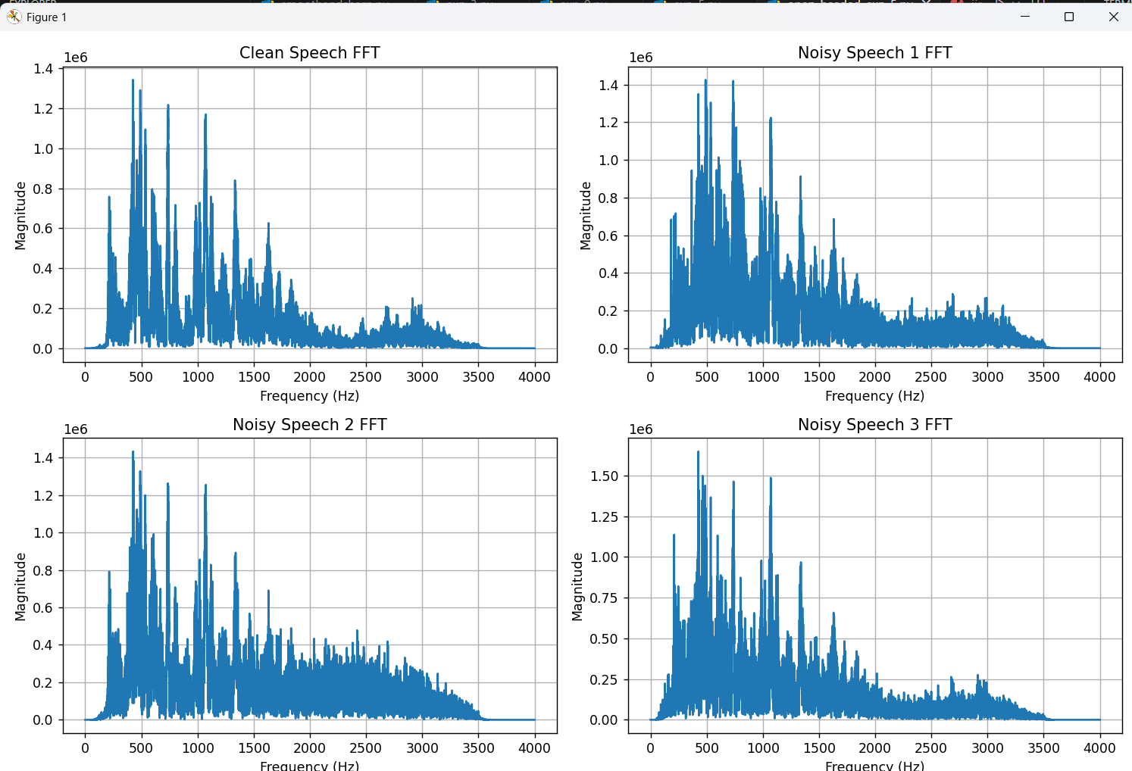

Conclusion:
The FIR low-pass filter designed using the Hanning window method with 31 taps and a normalized cutoff frequency of 0.2 exhibits the expected characteristics of a smooth and well-behaved low-pass filter .The impulse response is symmetric around the center tap, confirming linear phase behaviour, which ensures no phase distortion in the filtered signal. The freq response represents the low pas characteristics , the magnitude is high -40 – 50 db for the hanning window.

